Let’s Get into an Argument Mini-Unit on
Carbon Sequestration
Citizenship Teaching Experiment Mini-Unit

Written by: Beth Covitt (University of Montana) and Cornelia Harris (Cary Institute of Ecosystem Studies
Culturally relevant ecology, learning progressions and environmental literacy
Long Term Ecological Research Math Science Partnership
2012
Disclaimer: This research is supported by a grant from the National Science Foundation: Targeted Partnership: Culturally relevant ecology, learning progressions and environmental literacy (NSF-0832173). Any opinions, findings, and conclusions or recommendations expressed in this material are those of the author(s) and do not necessarily reflect the views of the National Science Foundation.


Let’s Get Into An Argument Mini-Unit
Teacher Topic Guide – Forest Carbon Sequestration

Table of Contents
Forest Carbon Sequestration Mini-Unit Overview 1
List of Articles 1
Teacher Notes for Teaching this Topic 2
Example Response Key for “What’s The Argument Here?” Handout (organized by article) 6
Example Response Key for “Evaluating Arguments in the Articles” Handout 9

Overview

This activity centers on the scientific question: What forest management practices are the most practical to maximize carbon sequestration? Following the Carbon Teaching Experiment (TE), students should have a good grasp that plants are carbon dioxide sinks and thus serve a key role in maintaining the natural carbon cycle on earth.
As the evidence mounts that anthropogenic sources are increasing levels of carbon dioxide and other greenhouse gases in the atmosphere, there is a growing need to discover carbon offsets or avenues that maximize carbon sequestration. While researchers attempt to uncover safe and economical strategies to sequester extra atmospheric CO2 it in important for all consumers/citizens to understand the natural carbon cycle and feasibility of these new technologies. The articles that are included in this mini-unit are centered on one aspect of carbon sequestration -- forests/trees as carbon sinks, though teachers can feel free to expand this discussion by including other natural carbon sinks (e.g. soil), as well as those produced by human ingenuity (see Activity 11 in the Carbon TE / Carbon Wedges game).

List of Articles

- Science Daily: Carbon Sequestration: Seeing The Forest For Its Trees:
Ecological Society Of America (2000, December 19). Carbon Sequestration: Seeing
The Forest For Its Trees. ScienceDaily. Retrieved from
http://www.sciencedaily.com /releases/2000/12/001219074241.htm
Readability level: 9th grade

- Old growth forests can actually contribute to global warming
Power, M. (2008). Old growth forests can actually contribute to global warming. Wired
Magazine: Issue 16.06
Readability level: 9th grade

- McKinley: A synthesis of current knowledge on forests and carbon storage in the United States
Mckinley, D.C. et al., (2011). A synthesis of current knowledge on forests and carbon storage in the
United States. Ecological Applications 21(6): 1902-1924.
Readability level = 12th grade
*Good article to highlight trade-offs involved in decision-making.

- Erickson: Future forests may soak up more carbon dioxide than previously believed, helping to buffer climate change
Erickson, J. (2011). Future forests may soak up more carbon dioxide than previously believed,
helping to buffer climate change. Retrieved from: http://www.snre.umich.edu
Readability Level: 12+

- Leighty: Effects of management on carbon sequestration in forest biomass in southeast Alaska.
Leighty, W., Hamburg, S., & Caouette, J. (2006). Effects of management on carbon sequestration in forest biomass in southeast Alaska. Ecosystems, 9 (7) 1051-1065.
Readability Level: 8th with data difficulty
NOTE: This article is very heavy with quantitative information, thus you might want to give it to those mathematically minded students of yours. You may need to support students with Pg and Tg units (Petragram = 10¹⁵, Teragram = 10¹²).
→The activity can still proceed without this article.

Teacher Notes for Teaching this Topic

Activity One (About 45 minutes):
Introduce Scientific Argumentation through class discussion and Video Experience

- Introduce the unit by telling students the class will be considering scientific arguments for the next few days. Ask students their ideas about what a scientific argument is and how scientific arguments are similar to and different from arguments that people have in their everyday lives. You may want to write students’ ideas on the board in two columns --- characteristics of scientific arguments and characteristics of everyday arguments.

- Handout page one of the Let’s Get Into An Argument student pages. Students should read the page. After students have finished reading, ask if anyone has any comments or questions.

- To introduce the topic and pique students’ interest, begin with a class discussion to help students relate this activity specifically to their understanding of the carbon cycle.
  - Engage – hold up a piece of wood and have students discuss where the mass of the wood came from?
- Explore – have students analyze the graph on the following page (you may want to project it so they can use the color-coded key).
- Explain – make sure students understand the words source and sink and that plants, in this case tree’s are carbon sinks.
Questions to check for understanding:
- What type of vegetation is the largest carbon sink?
- Why has above ground Carbon storage changed?
- Where did that Carbon go?

Next, tell students they will watch a video to provide a real world example that they can apply the terms they’ve just read about. A specific Carbon Example can be found at:
http://www.youtube.com/watch?v=P5SV3pVGsno&feature=related
See below for an analysis of the scientific argument outlined in this video.

- At this point, students should be organized into small groups of about 3 to 4 students. Handout pages 2 and 3 of the student pages and ask students to discuss and answer the questions on page 2 in their small groups.

- After students have discussed and answered the questions in their small groups, lead a whole class discussion of the questions on the handout. Direct each question to a different group. After a group answers, ask the other groups if they agree or if they have anything they would change or add. By the end of this discussion, students should have an initial understanding of the introduced terms, including as related to the video they watched.

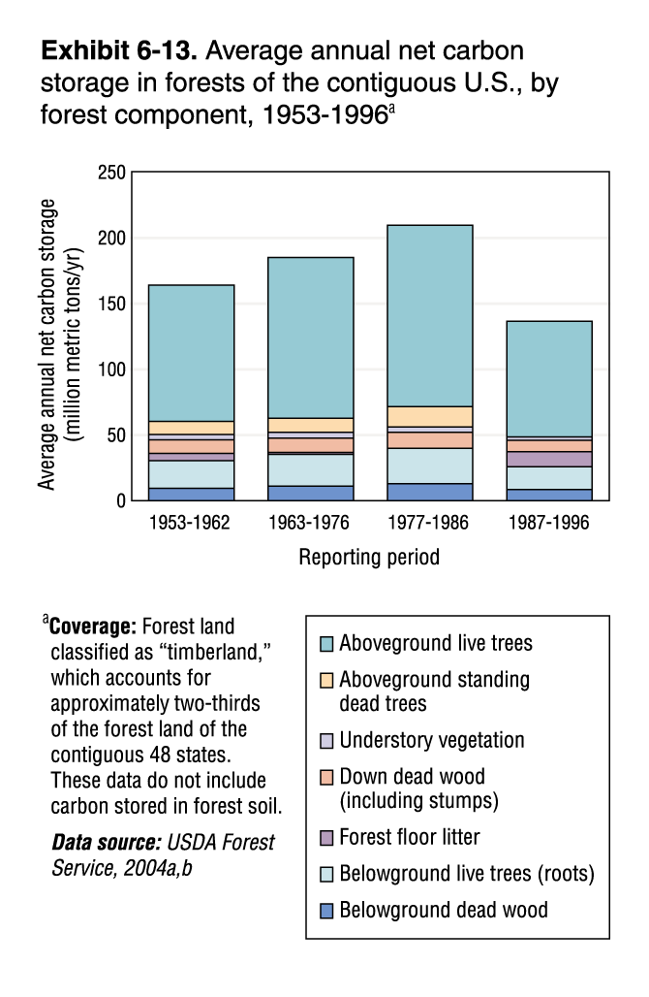

Example Responses to Video Questions for Teachers

U-Tube Video: Wild Thyme Farm Forestry: Forest Carbon Offset Program
http://www.youtube.com/watch?v=P5SV3pVGsno&feature=related

- What scientific question is addressed in the video?
Can forests be used to offset carbon emissions? Can Carbon sequestration be optimized through forest management?

- What scientific argument did the narrator make?
  - What was his claim?
Overall: Wild Thyme forests are managed to maximize carbon sequestration
Other:
- CO2 emissions contribute to global warming
- Forests in the US capture 10% of the C emissions
- 25% of CO2 emissions are caused by the loss of forestlands
- FSC’s recommendations are valid and will produce better results than the conventional short-term exchange clear-cut approach.
- By maintaining a forest management system they (Wild Thyme Farm Forestry) can conserve more Carbon over a hundred-year period.

  - What was his evidence?
- The combination of trees that they have in their forests is managed according to Forest Stewardship Council (FSC) guidelines.
- Carbon model evaluates the carbon benefits that can be achieved by improved forest management.

  - What was his reasoning?
- Forests are carbon-sequestration machine
- Implied – trees sequester CO2

- What socio-scientific issue or issues is this scientific argument relevant to?
Students’ responses will vary but they may have something like:
-Climate change
-How forests can help sequester excess CO2 in the atmosphere

- If you wanted to decide what ought to be done about the socio-scientific issue you’ve identified, what other scientific questions in addition to the one in the video would you want to consider?
Students’ responses will vary but they include questions such as:
-How generalizable is the FSC’s recommendations to other forest biomes throughout the world?

- What non-scientific questions would you want to consider?
Students’ responses will vary, but could include:
-What is and who is involved in the FSC? What are their specific recommendations?

Example Response Key for “What’s The Argument Here?” Handout (organized by article)

Titles of Articles Provided:
1. Carbon Sequestration: Seeing The Forest For Its Trees

2. Old growth forests can actually contribute to global warming

3. A synthesis of current knowledge on forests and carbon storage in the United States

4. Future forests may soak up more carbon dioxide than previously believed, helping to buffer climate change
5. Effects of management on carbon sequestration in forest biomass in southeast Alaska.

What socio=scientific issue do the articles address?
-Climate change
-How forests can help sequester excess CO2 in the atmosphere

What scientific question do the articles address?
What forest management practices are the most practical to maximize carbon sequestration?

Example claims, evidence and reasoning are provided below.

Article | Claim | Evidence | Reasoning
1. Carbon Sequestration: Seeing The Forest For Its Trees | The researchers discovered that carbon sequestration was significantly boosted when the composition of tree stands included nitrogen-fixing trees. + They discovered that the acres inter-planted with albizia trees (Albizia falcataria) were able to sequester more carbon than areas where eucalyptus trees were planted alone. | The researchers found that in stands where the two species were inter-planted, the forest contained twice as much carbon in trees as monocrop areas. In addition, areas of pure albizia sequestered about 20 percent more carbon in soil than did the pure eucalyptus stands. | "Carbon sequestration is the balance of inputs and outputs from a system," … "What we've shown here is that carbon outputs from soil are lower in stands that have more nitrogen-fixing trees. If decomposition is inhibited because of nitrogen inputs, then increased biological nitrogen fixation, nitrogen fertilization and nitrogen deposition may promote carbon sequestration."
2. Old growth forests can actually contribute to global warming | Over its lifetime, a tree shifts from being a vacuum cleaner (sink) for atmospheric carbon to an emitter (source). | Canadian government report found that during many years their forests actually give up more carbon from decomposing wood than they lock down in new growth. | Doesn’t come out and say it exactly, but can infer that younger trees photosynthesis is the dominant process, older trees (rot or burn) and CO2 gets released during decomposition or combustion.
3. A synthesis of current knowledge on forests and carbon storage in the United States | 60% of the carbon lost through deforestation and harvesting has yet to be recovered and the biological potential for forest sector carbon mitigation is large. | Management strategies can increase carbon mitigation above the current 162-256 Tg C / yr.  However tradeoffs = loss of agricultural land to forests, and possible increase in emission of other GH gasses such as CH4 and NO with movement of forest products. | Need to consider trade-offs with plans to increase forest area due to affects on other systems.
4. Future forests may soak up more carbon dioxide than previously believed, helping to buffer climate change | Forests appear to respond to increased levels of CO2 by soaking up more of the GH gas. | Evidence - In the study, the trees bathed in elevated carbon dioxide continued to grow at an accelerated rate throughout the 12-year experiment. The CO2-soaked trees grew 26 percent more than those exposed to normal levels of carbon dioxide | Reasoning - In addition to trapping heat, carbon dioxide is known to have a fertilizing effect on trees and other plants, making them grow faster than they normally would.
5. Effects of management on carbon sequestration in forest biomass in southeast Alaska. | Managing the Tongass forest by halting all timber harvesting would be economically beneficial if harvesting the forest was halted from 1995-2095, to the total of $4-$7 million US dollars annually. | Spatial GIS data combined with forest inventories estimate that the Tongass sequesters 2.8 +/- 0.5 Pg C and while losing (due to management) was estimated at 6.4-17.4 Tg C. In addition if forests were managed carbon flux would be reversed due to the “rate of carbon accumulation in second-growth forests and to the amount of carbon left in standing biomass after harvest”. | Not explicit but reasoning should stem from plants sequester more CO2 through photosynthesis than give off during respiration.

Example Response Key for “Evaluating Arguments in the Articles” Handout
In this section, provide an example response key for the handouts below pertaining to the topic.

Scientific Argument, Article 1. Carbon Sequestration: Seeing The Forest For Its Trees

Restate the claim for this argument:
Carbon sequestration is significantly boosted when the composition of tree stands included nitrogen-fixing trees

Criterion (Factor) | Strength (S), Neutral (N), or  Weakness (W) | Explain why the scientific argument is strong or weak for each criterion you list.
- Is there scientific evidence to support the claim?  - Have the results been replicated? | Relatively Strong for both | From the article: “The researchers suggest that nitrogen which is added to the soil by the albizias may be inhibiting the decomposition of old, sugarcane derived, soil carbon relative to eucalyptus. Many previous studies have demonstrated that nitrogen additions tend to inhibit humus decomposition in laboratory experiments. This study, however, is the first to examine the possibility that nitrogen additions may decrease carbon turnover in the field.”
- Is the sample size for collecting data sufficient (in other words, is the sample big enough)? | Not enough information
- Was the data collection procedure for gathering evidence rigorous and careful? | Relatively Strong | Even though the article does not delve into data collection procedures, this criteria could be considered strong since they had three experimental plots and established tree stands.
- Have the results been published in a peer reviewed, reputable publication? | Yes – strong | December edition of Ecology (Vol. 81, No. 12)

Scientific Argument Article 2: 2. Old growth forests can actually contribute to global warming

Restate the claim for this argument:
Over its lifetime, a tree shifts from being a vacuum cleaner (sink) for atmospheric carbon to an emitter (source).

Criterion (Factor) | Strength (S), Neutral (N), or  Weakness (W) | Explain why the scientific argument is strong or weak for each criterion you list.
- Is there scientific evidence to support the claim?  - Is the sample size sufficient? | Neutral | The article stated: “The report (from the Canadian Government) found that during many years, Canadian forests actually give up more carbon from decomposing wood than they lock down in new growth”. There does not seem to be enough information / scientific evidence, nor information on sample size to rate this as strong.
- Have the results been published in a peer reviewed, reputable publication? | Weak | Wired Magazine is a popular magazine that is not peer reviewed
- Did someone who might have a bias fund or carry out this work (for example, was the work paid for a company that has an interest in getting certain results)? | Also Weak | Same as above, it seems like the Wired Magazine author was trying to push some scientists buttons.

