Old growth forests can actually contribute to global warming.
Reading to accompany Carbon Sequestration Citizenship Mini-Unit

Written by: Power, M.
Culturally relevant ecology, learning progressions and environmental literacy
Long Term Ecological Research Math Science Partnership
2012
Disclaimer: This research is supported by a grant from the National Science Foundation: Targeted Partnership: Culturally relevant ecology, learning progressions and environmental literacy (NSF-0832173). Any opinions, findings, and conclusions or recommendations expressed in this material are those of the author(s) and do not necessarily reflect the views of the National Science Foundation.

Old growth forests can actually contribute to globalwarming.
Power, M. (2008) Wired Magazine: Issue 16.06
Readability level: 9th grade

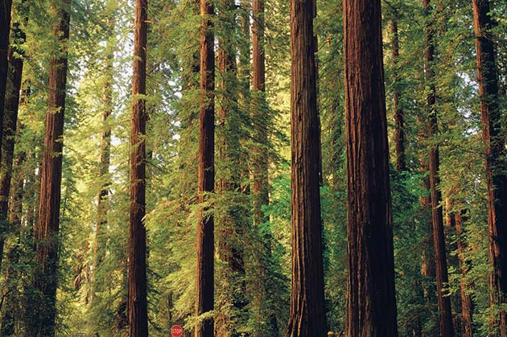

Ronald Reagan's infamous claim that "trees cause more pollution than automobiles" contained a grain of truth. In warm weather, trees release volatile chemicals that act as catalysts for smog. But the Gipper didn't mention another point that's even more likely to make nature lovers blanch. When it comes to fighting climate change, it's more effective to treat forests like crops than like majestic monuments to nature.
Over its lifetime, a tree shifts from being a vacuum cleaner for atmospheric carbon to an emitter. A tree absorbs roughly 1,500 pounds of CO₂ in its first 55 years. After that, its growth slows, and it takes in less carbon. Left untouched, it ultimately rots or burns and all that CO₂ gets released.
Last year, the Canadian government commissioned a study to determine the quantity of carbon sequestered by the country's woodlands, which account for a tenth of global forests. It hoped to use the CO₂-gathering power of 583 million acres of woods to offset its Kyoto Protocol-mandated responsibility to cut greenhouse gas emissions. No such luck. The report found that during many years, Canadian forests actually give up more carbon from decomposing wood than they lock down in new growth.
A well-managed tree farm acts like a factory for sucking CO₂ out of the atmosphere, so the most climate-friendly policy is to continually cut down trees and plant new ones. Lots of them. A few simple steps: Clear the oldest trees and then take out dead trunks and branches to prevent fires; landfill the scrap. Plant seedlings and harvest them as soon as their powers of carbon sequestration begin to flag, and use the wood to produce only high-quality durable goods like furniture and houses. It won't make a glossy photo for the Sierra Club's annual report, but it will take huge amounts of carbon out of the atmosphere.

